Project 5: 32-Bit ALU

How to run DRC and LVS check
For DRC:
In the rules file enter: /users/ugrad/vttang/EECS170D/ncsu-cdk-1.6.0/techfile/divaDRC.rul and uncheck _TechLib_tsmc03d

For LVS:
Get extracted file first:
- Verify enter rule file as /users/ugrad/vttang/EECS170D/ncsu-cdk-1.6.0/techfile/divaEXT.rul
- Make sure schematic matches extracted:
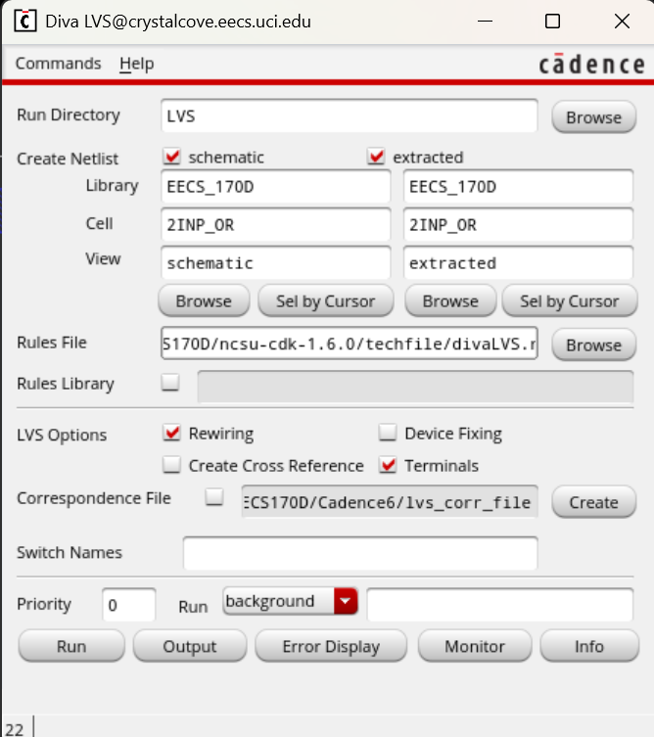

- Enter the same rules file except change the end to divaLVS.rul

Grid display original settings:
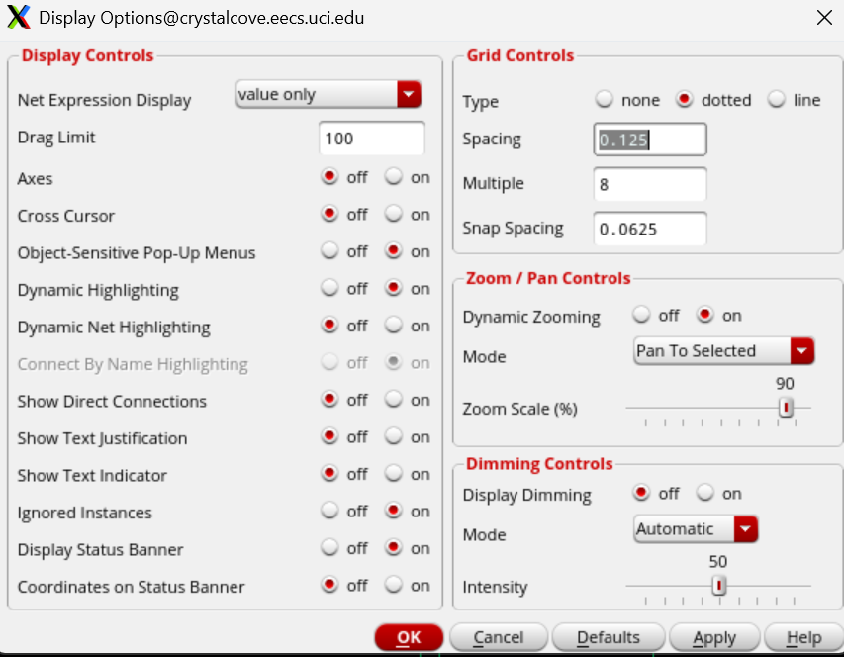

1-bit ALU schematic
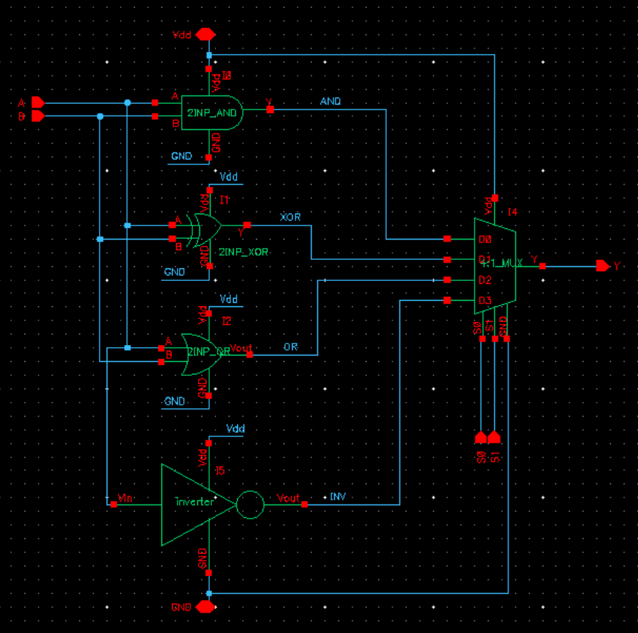

1-bit ALU layout

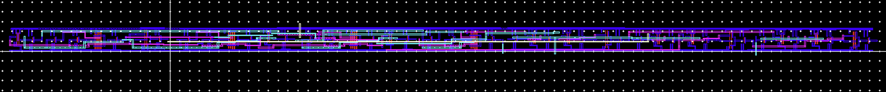

1-bit ALU LVS check
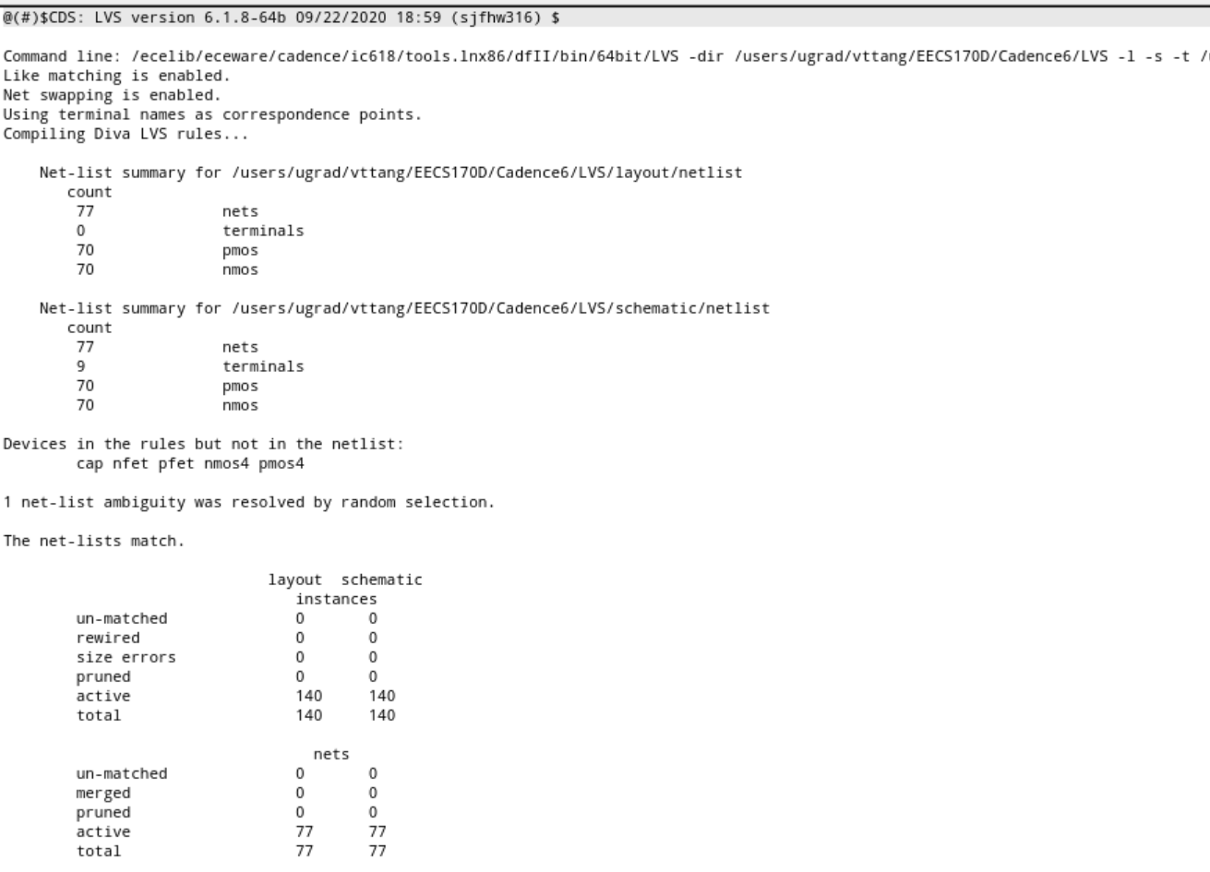
4-bit ALU schematic
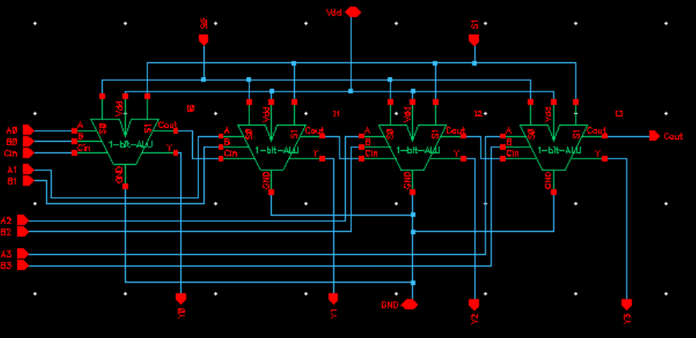
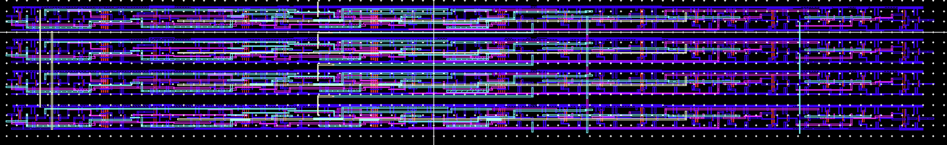
4-bit ALU layout
4-bit ALU LVS check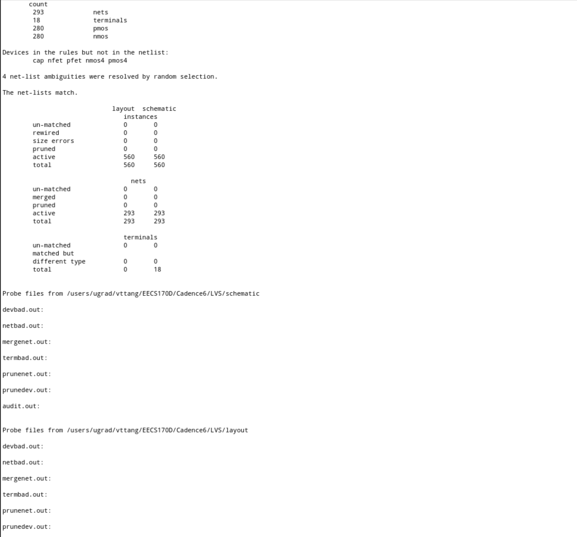

32-bit ALU Schematic
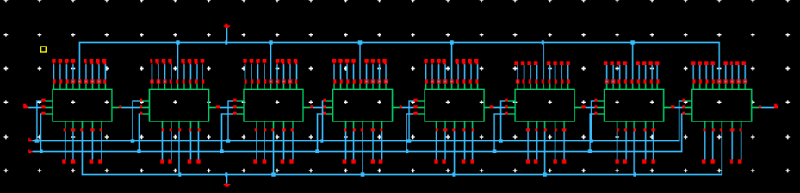
32-bit ALU Layout
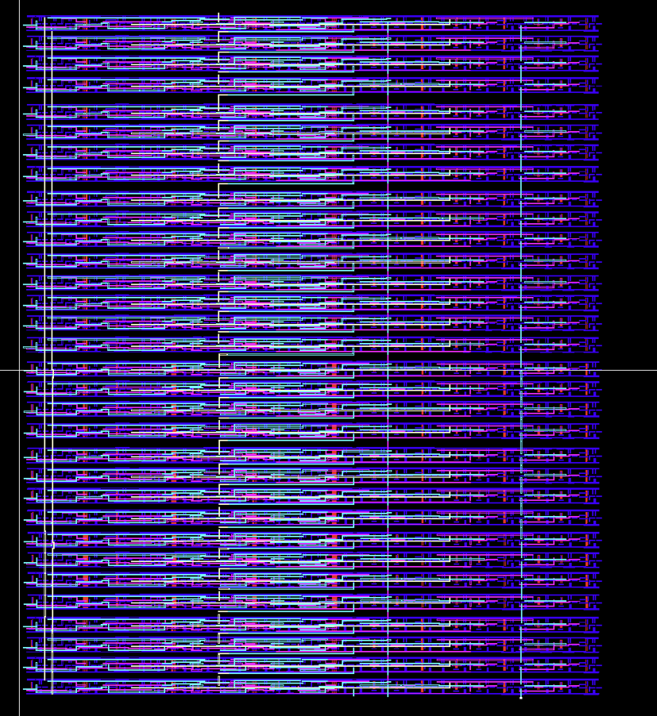
32-bit ALU DRC
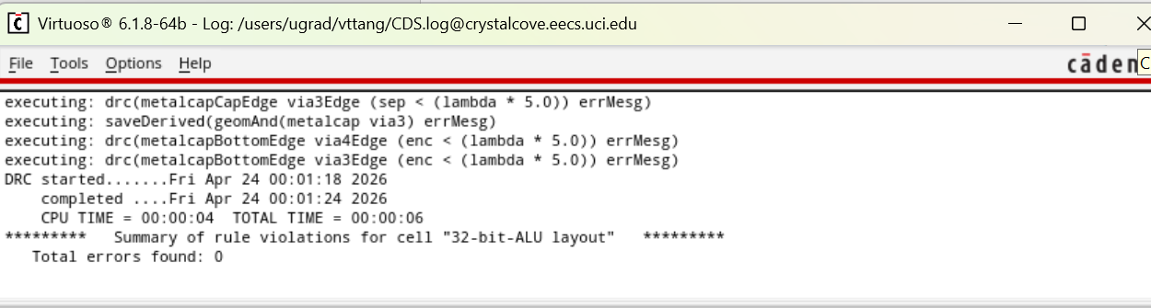

32-bit ALU LVS check:
